**SOLUTION ARCHITECTURE**

**CIRCUIT DESIGN:**

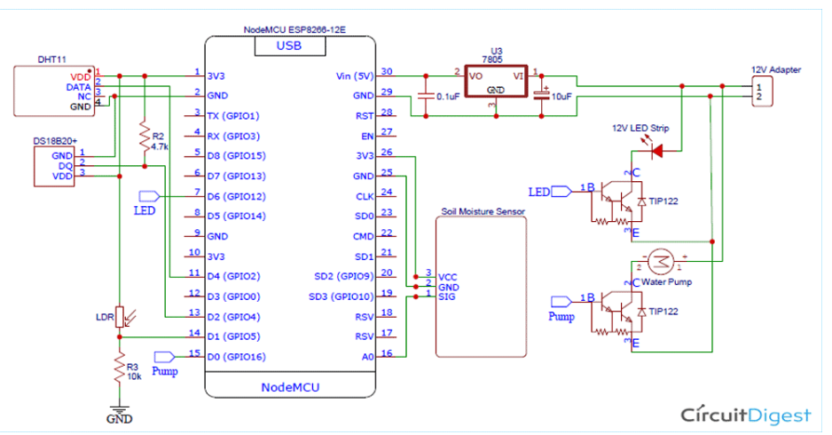

**TECHNICAL ARCHITECTURE:**

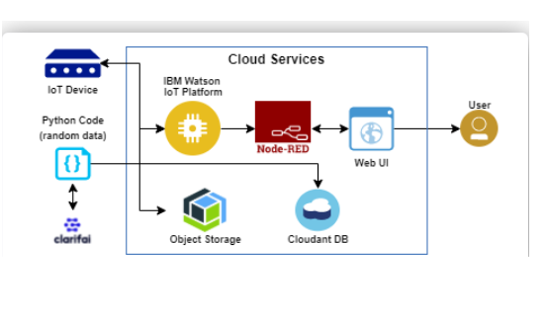

**SOLUTION:**

Smart Farming has enabled farmers to reduce waste and enhance productivity with the help of sensors (light, humidity, temperature, soil moisture, etc.) and automation of irrigation systems. Further with the help of these sensors, farmers can monitor the field conditions from anywhere. Internet of Things based Advanced Farming is highly efficient when compared with the conventional approach. The applications of intelligent Agriculture solutions not only target conventional, large farming. With operations, but could also be new levers to uplift other growing or common trends in agricultural like organic farming, family farming (complex or small spaces, particular cattle and/or cultures, preservation of specific or high-quality varieties, etc.), and enhance highly transparent Farming.